LibbieSummers.com/Red Velvet Productions
Editing in iMovie On Your Computer

Step 1: Import the video clips onto your computer from your iPhone or HD card to a new folder on your desktop. It makes the clips easier to find and import into iMovie!
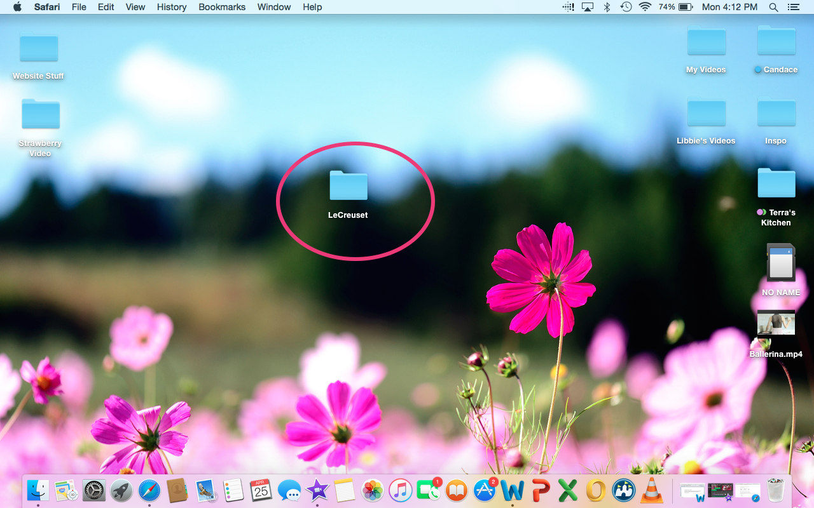

Step 2: Open iMovie.

Step 3: Import your clips. Press the import button.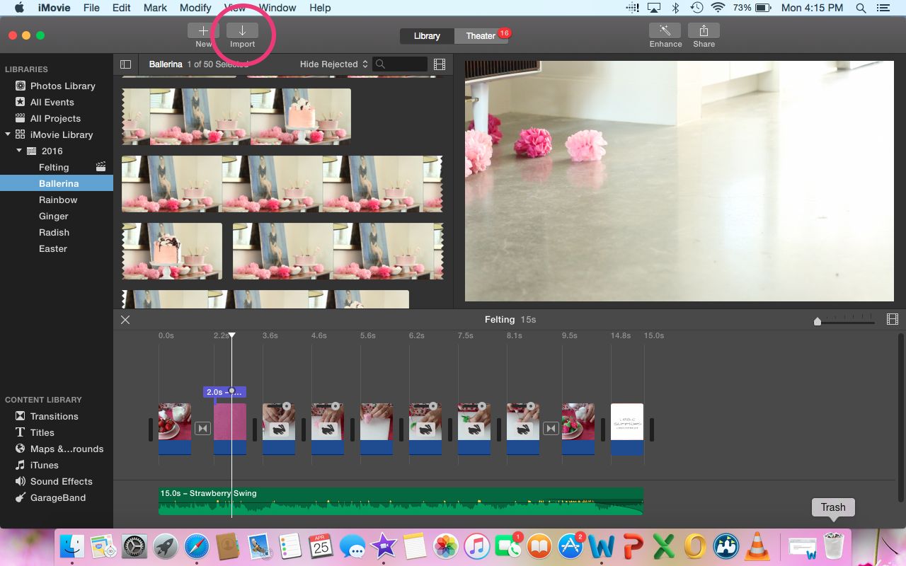

Step 4: Create a new event folder inside of iMovie and label it with the title of your new movie. After labeling your event find the folder on the desktop with all the clips you would like to import.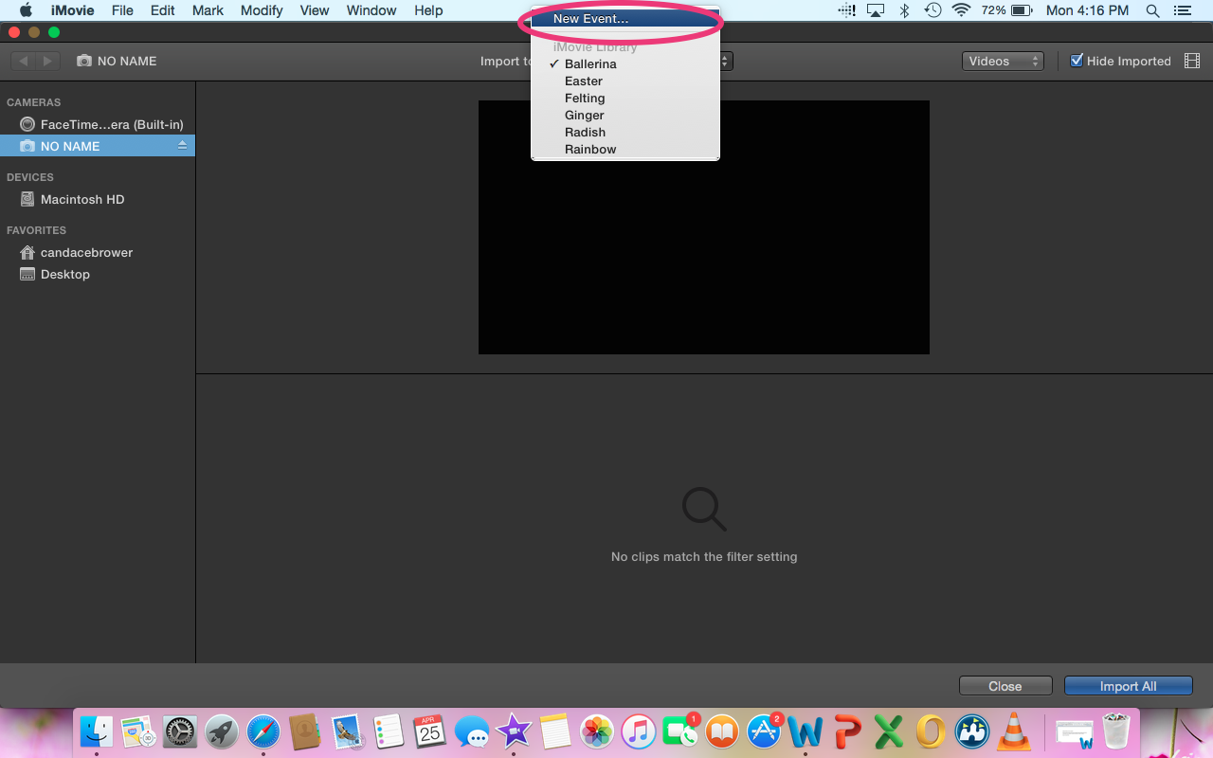

Step 5: Highlight all of the clips and press “import all”.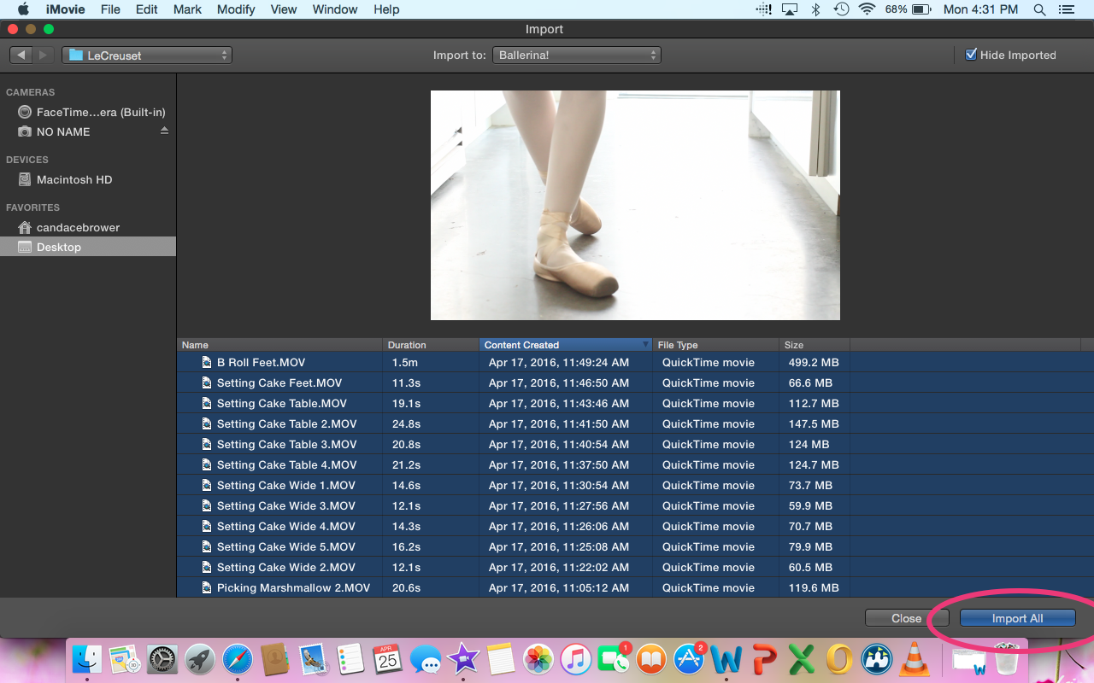

Step 6: Now that all your clips are imported you will want to create a fresh editing timeline. To do so, go to the upper left where you see a plus sign with the word “NEW” and click. It will then ask the question of “Movie or Trailer” and you should choose movie. It is a more suitable option for your Instagram mini movies.
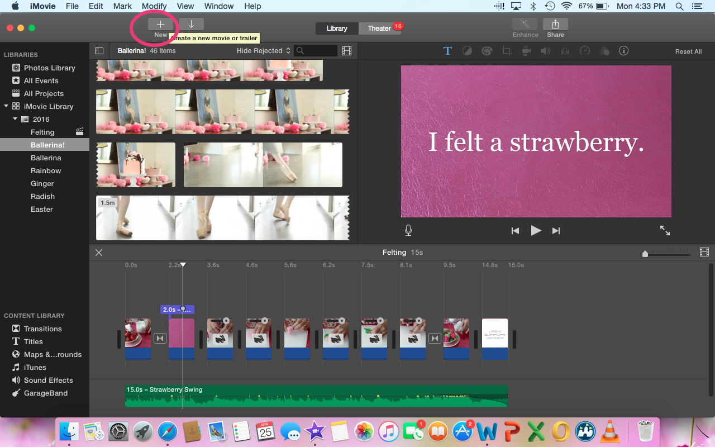
Step 7: iMovie gives the option of themes, but the best option is no theme. Name your movie and choose the event that your clips are in. Press OK. 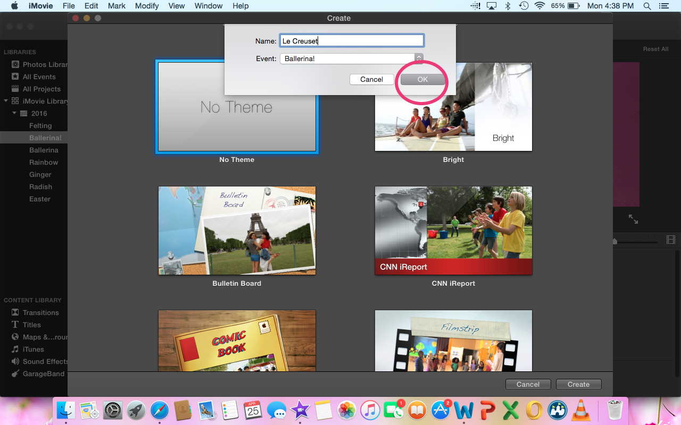

Step 8: Now, you will have a new timeline that is ready for you to start editing your project. To the left under The Libraries tab you should see the event you created. I entitled mine Ballerina! This is where you will find all the clips to be edited. 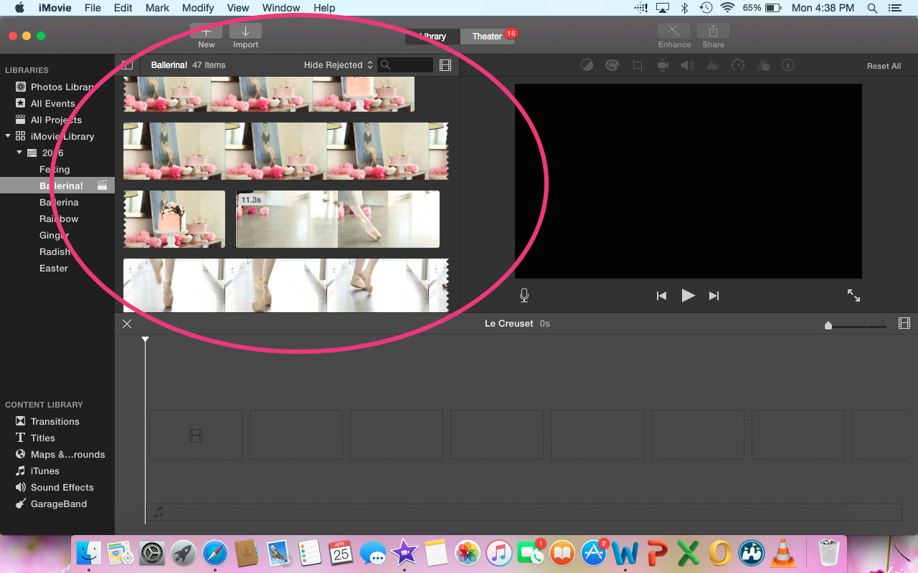

Step 9: Music is key to telling your story. To import music find the iTunes tab under content library. There you can search for the song you have chosen to use.
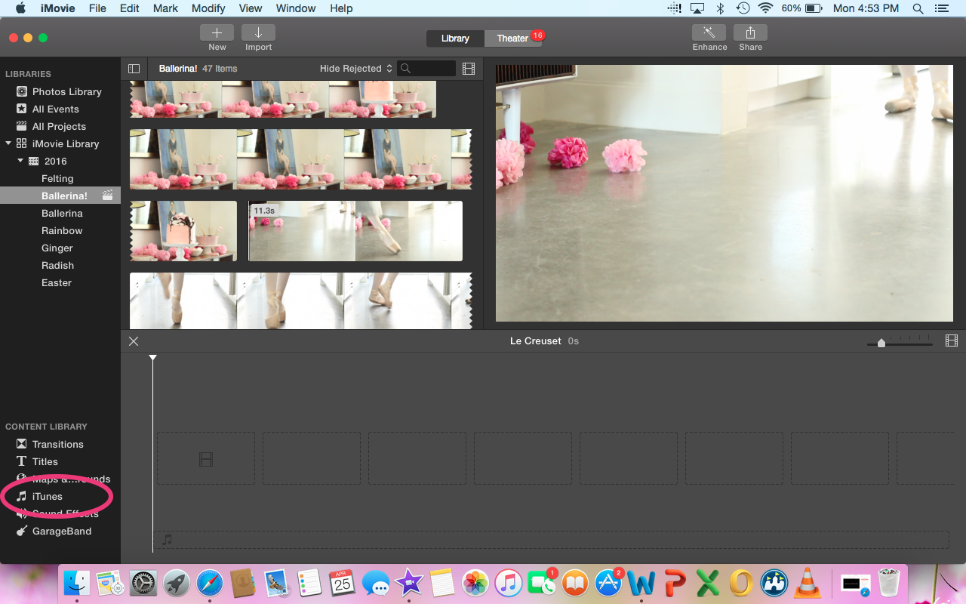

Step 10: Play the song through and decide what part of the song you want to use for your project. To select, click and drag. You will see a yellow box appear around your selection. Press the plus button and it will pop down into your timeline. 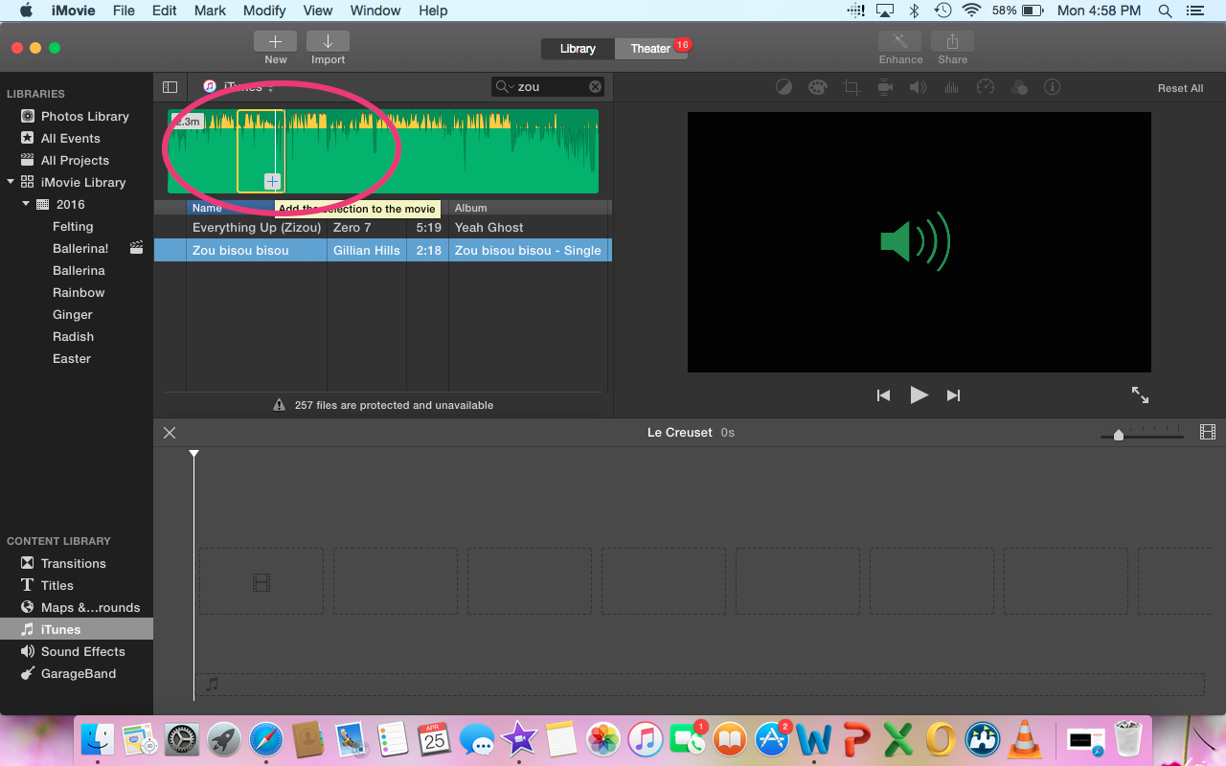
Step 11: Now that the music has been selected it is time to bring in your clips! To do so, hover over the clips in your event window. By hovering over the clips you can choose the start and end of your clips without having to play them. When you find the start, click and drag, a yellow box will appear just like with the music selection. When you reach your preferred stopping point, stop dragging and press the plus button and the clip will pop down into your timeline. 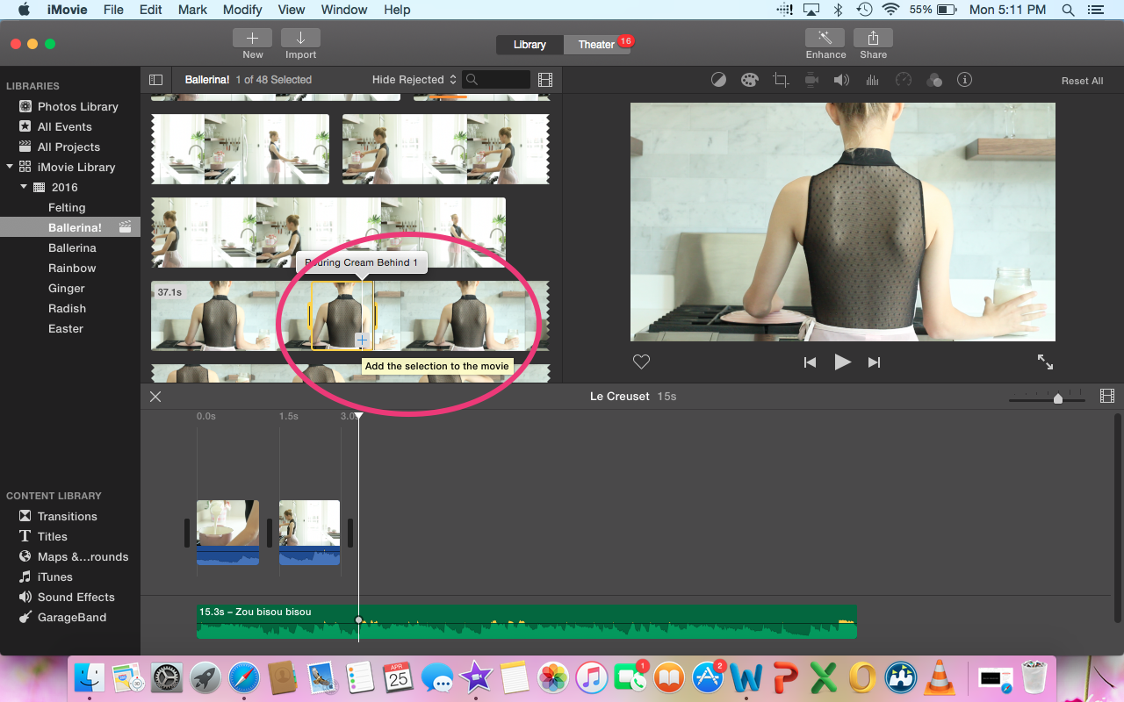
Step 12: Repeat this process until you have selected all the clips you would like to use in your project. If you decide you want a clip in a different place all you have to do is click (putting the yellow box around it) then drag the clip to the place in your timeline where you would like it to go. If a clip is too long you have two options, either click and drag to the left or split the clip by going up to “MODIFY” and pressing “SPLIT CLIP” or the easier option is just pressing “Command+B” on your keyboard and delete the section you don’t want by clicking it (the yellow box will then appear around the clip) and press delete.
Optional 1: Dragging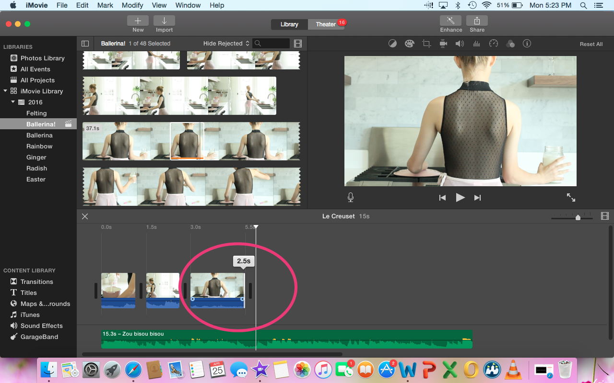
Option 2: Splitting and deleting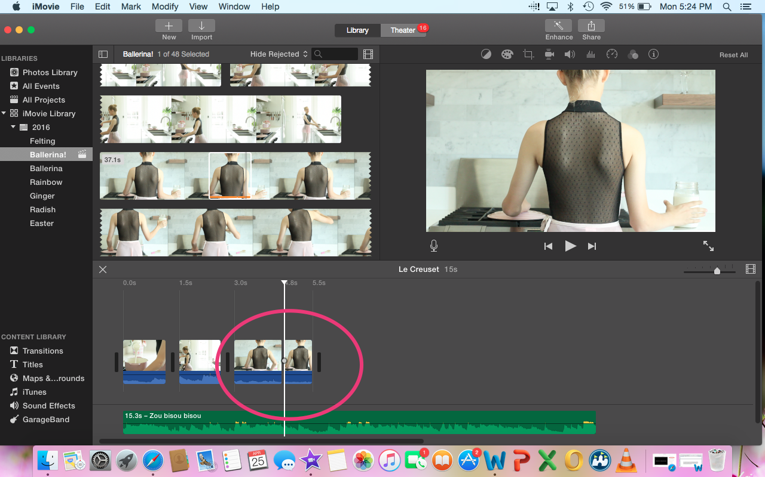
If the clip is too short you can drag to the right to extend it to the length you would like.

Tips and Tricks:

Make sure to mute the audio on the clips if you are using music. You can adjust the volume of the clips by clicking them (the yellow box will appear). There are options to bring the volume up, down, or mute entirely. You can click on the first clip, press Shift and click the last clip to highlight all of the clips. That way you don’t have to mute each section individually.
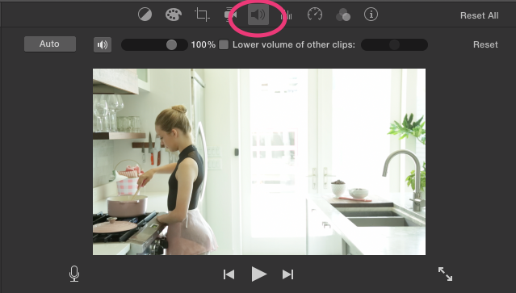

There is an option to speed up or slow down your clips. You can adjust the speed by clicking the speedometer. It will give you options for fast and slow as well as customizable speed by percentage. 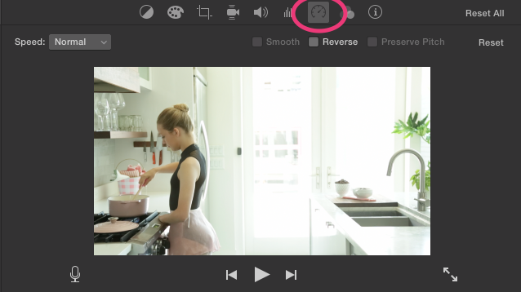

Hopefully your clips will be beautiful from the start and won’t need any adjusting of color or brightness, but if you feel like you need to brighten up, saturate, or adjust the tone of your clips click the artist palate and iMovie will give you those options. Highlight the clip you want to change, click and drag to the left or right to adjust the brightness, saturation, or tone until you are satisfied with the look of your clips.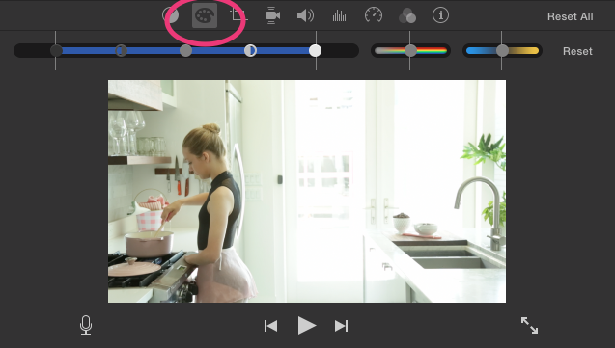

If you would like to add transitions from clip to clip instead of just cutting from clip to clip press the “TRANSITIONS” tab under the content library. Choose the transition you like, click and drag in between the clips where you want to the transition to appear. 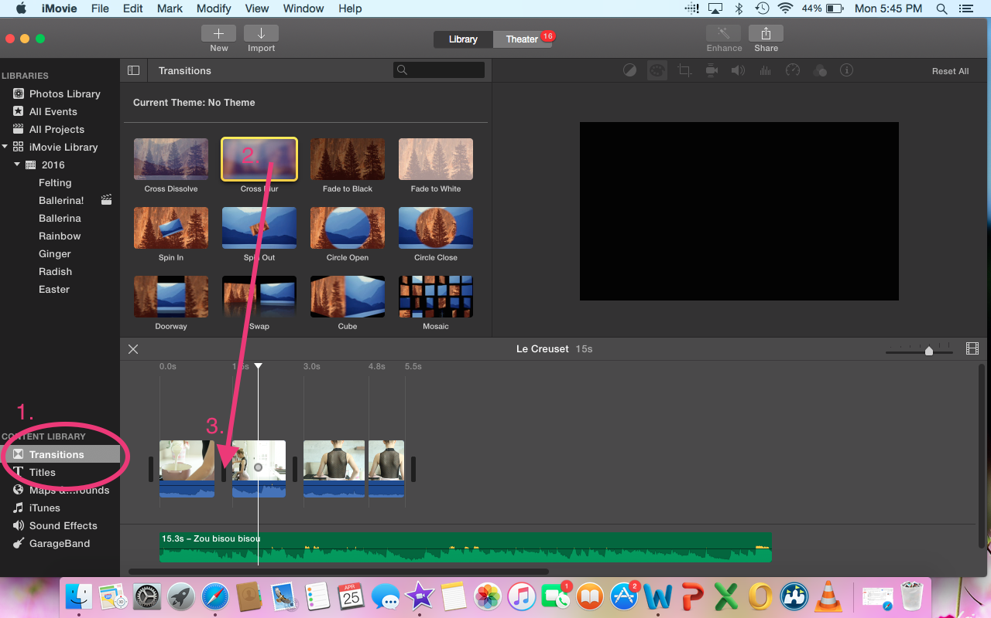
If you would like to add a title to you movie press the “TITLES” tab under the content library. Choose a title and drag to the place you want it to appear in the movie. If you want the title to appear before your clips start drag to the front of your project, or the title can appear on the clips by dragging it over the top of the clip (where you want it to appear) and releasing. You can shorten or lengthen the clip by clicking and dragging from right to left. iMovie also gives you the option to change font, color, and size.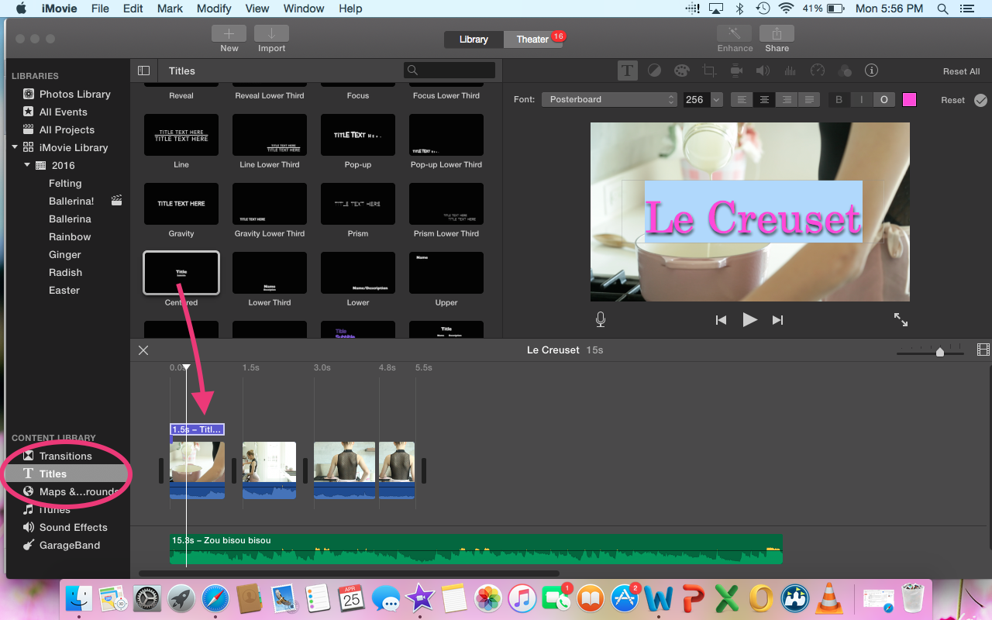
To stop the music from ending abruptly, use the fade in/fade out option. To fade the song in find the small gray circle in the middle of the audio line and drag to the left. To fade the music out find the small gray circle in the middle of the audio line and drag to the right.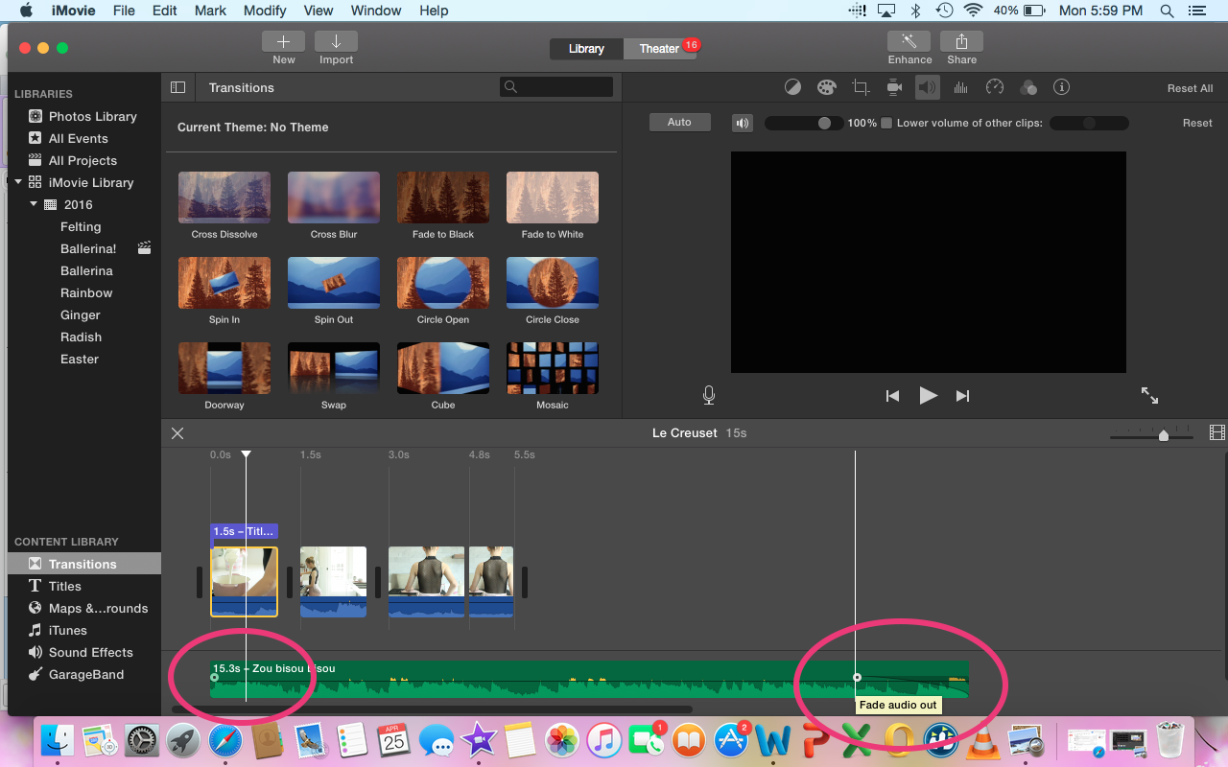
Sometimes you want to make changes to your movie without changing the original. Since iMovie saves as you go along there is no option for you to save different versions. What you can do is make a duplicate movie. That way you can change things around and experiment without fear of losing your original movie. Click on the all projects tab and find your movie. Click and highlight the movie (a yellow box will be around it). Move up to the edit button and press “DUPLICATE MOVIE” 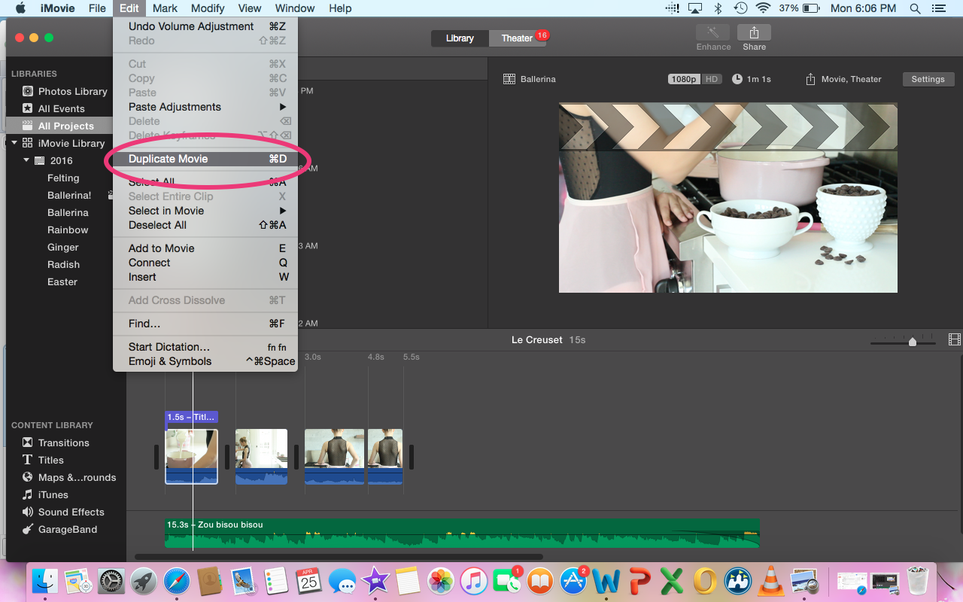

Now that you have completed your project it is time to export and upload to your Instagram! To export go to the upper right and press “SHARE” then press “FILE”.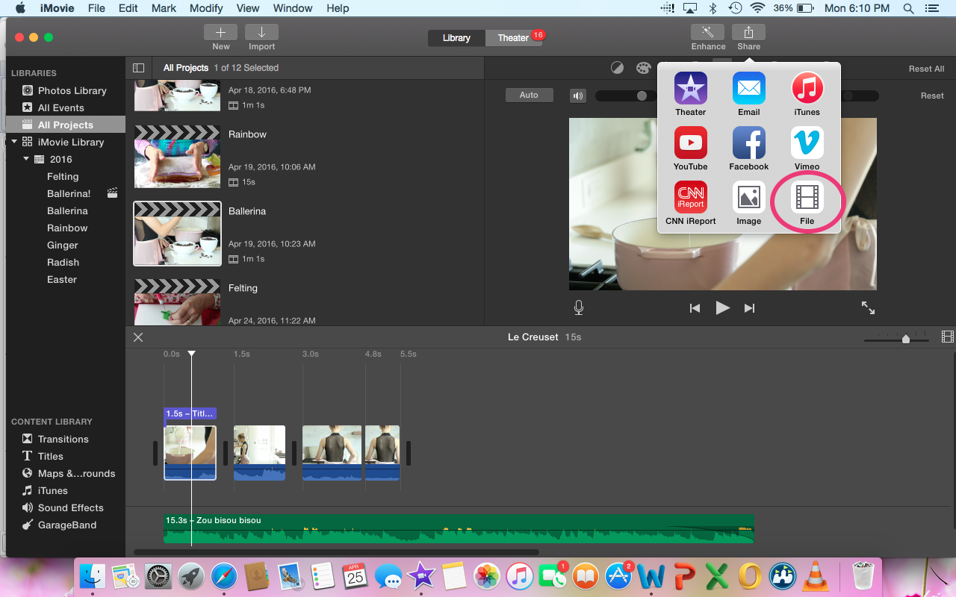
iMovie will then ask you to name your movie, give it a description, what format you would like it in, the resolution, and the quality. Always choose the best quality when you can. The highest quality Instagram will accept is “HIGH”. If you are uploading to YouTube you can choose “BEST (PRORES)”. Then click next. I always save it to my desktop so I can find it easily.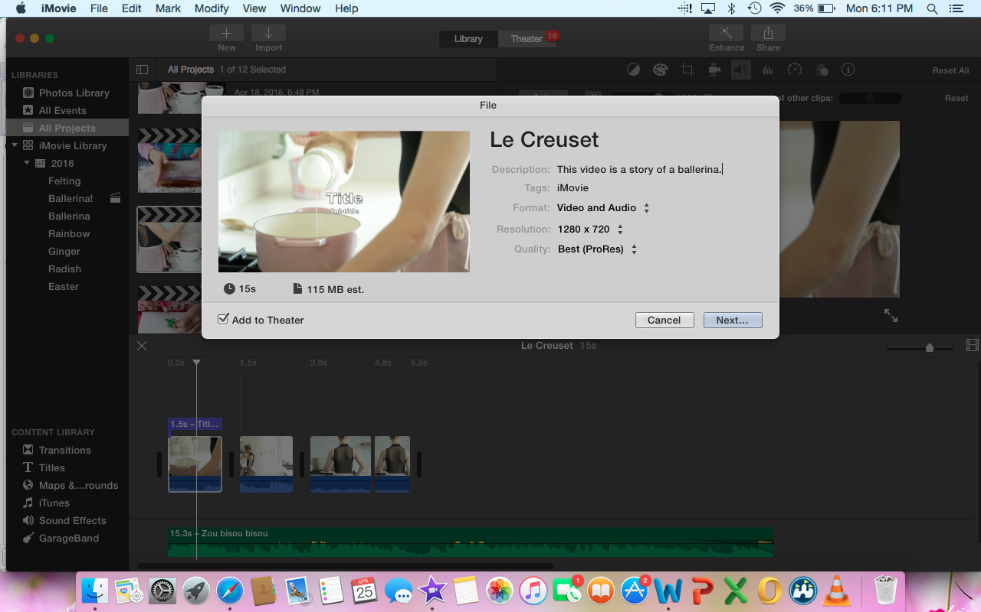

From there I either email it to myself and save to my phone, or save to my Dropbox and download the movie to my phone. Simply go to Instagram and upload it through the video section of the app. If you are uploading to YouTube the process is much easier. Just find the video on your desktop with the correct quality and upload it to YouTube!

VOILA! You have created a story for you and your followers to enjoy.

